МИНИСТЕРСТВО ОБРАЗОВАНИЯ РЕСПУБЛИКИ БЕЛАРУСЬ

Учреждение образования

«Белорусский государственный технологический университет»

Отчет по лабораторной работе №7

ТЕСТИРОВАНИЕ ЦП

Выполнил: студент

факультета ИДиП

специальности ИСиТ

3-его курса 8-й группы

Кебич Михаил Михайлович

# **Акронимы (acronyms)**

|  |  |
| --- | --- |
| **MIPS** | Millions of Instructions per Second |
| **MOPS** | Millions of Operations Per Second |
| **MFLOPS** | Millions of FLOating Point Operations per Second (MegaFlops) |
| **GFLOPS** | Billions of FLOating Point Operations Per Second (GigaFlops) |

# **Арифметический тест процессора**

(Processor Arithmetic)

Benchmarks the ALU and FPU processor units. Shows how your processors handle arithmetic and floating point instructions in comparison to other typical processors.

Such operations are used by software in typical tasks.

* Multi-Processor (SMP) support for up to 32/64 CPUs & SMT.
* Test takes about 2 minute on P6-class PCs.
* **Command Line Switch**: CPUAABench
* **Requirements:** None

**Explanations**

* MP Dhrystone (MIPS) ALU/SSE(4) (Arithmetic) Benchmark
* MP Whetstone (MFLOPS) FPU/SSE(2/3) (Floating Point) Benchmark

**Results Interpretation**

**Dhrystone** (MIPS) - higher results are better, i.e. better integer performance.

**Whetstone** (MFLOPS) - higher results are better, i.e. better floating-point performance.

**Performance vs. Speed** (MOPS/MHz) - higher ratios are better, i.e. better performance efficiency.

**Performance vs. Power** (MOPS/W) - higher ratios are better, i.e. better performance per power drawn.

**Performance vs. Price** (MOPS/$) - higher ratios are better, i.e. better performance per cost.

**Capacity vs. Price** (MHz/$) - higher ratios are better, i.e. faster processor per cost.

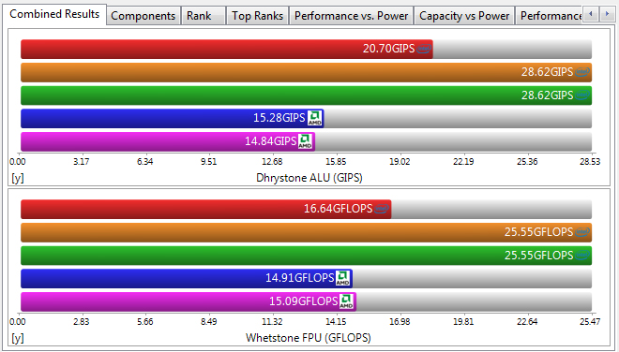

Комбинированный график (Combined Results)

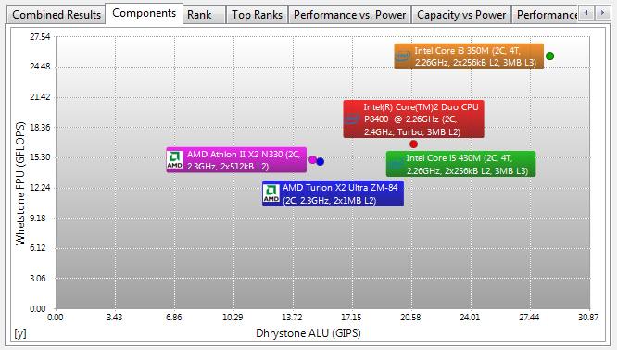

График компонентов (Components)

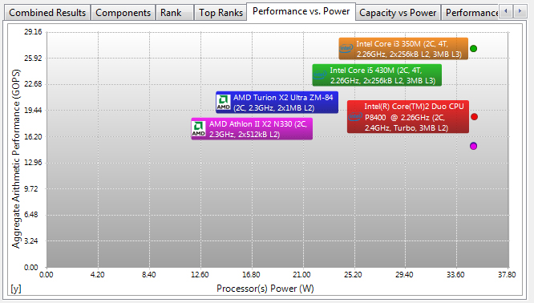

Производительность - Мощность (Performance vs Power)

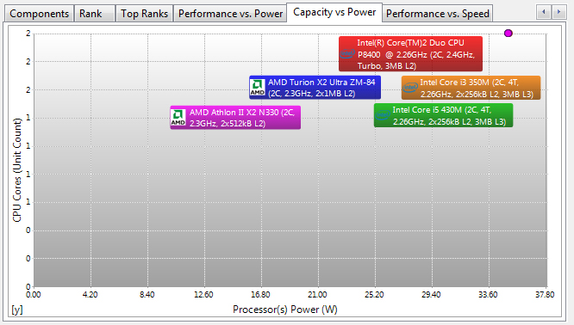

Емкость - Мощность (Capacity vs Power)

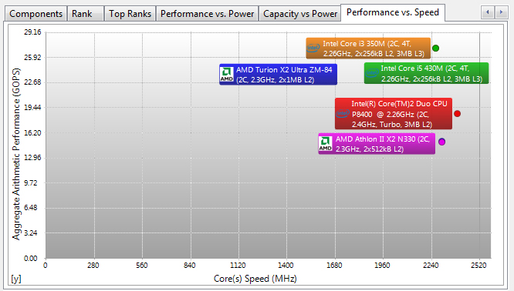

Производительность - Скорость (Performance vs Speed)

# **Мультимедийный тест процессора**

(Processor Multi-Media)

Benchmark the (W)MMX(2), SSE(2/3/4), AVX processor units. Shows how your processors handle multi-media instructions and data in comparison to other typical processors.

Such operations are used by more specialised software, e.g. image manipulation, video decoders/encoders, games.

* Multi-Processor (SMP) support for up to 32/64 CPUs & SMT.
* Test takes about 2 minute on P6-class PCs.
* Command Line Switch: CPUMMBench
* **Requirements:** (Wireless) MMX(2), SSE(2/3/4) or AVX recommended

**Explanations**

The test involves the generation of Mandelbrot Set fractals that are used to realistically describe and generate natural objects such as mountains or clouds. By using various multi-media extensions better performance is achieved.

**Integer test - using integer data:**

* MP SSE4.x, SSSE3, SSE3, SSE2 is used for better performance if supported.
* MP SSE (Streaming SIMD) is used for better performance if supported.
* MP Enhanced MMX is used for better performance if supported.
* MP (Wireless) MMX is used for better performance if supported.
* MP ALU is used otherwise.

**Single/Double Floating-point test - using floating point data:**

* MP AVX, SSE2 is used for better performance if supported.
* MP SSE (Streaming SIMD) is used for better performance if supported.
* MP FPU is used is used otherwise.

**Results Interpretation**

**Multi-Media Integer** (Pixels/s) - higher results are better, i.e. better integer performance.

**Multi-Media Single/Double Float** (Pixels/s) - higher results are better, i.e. better floating-point performance.

**Performance vs. Speed** (Pixels/s/MHz) - higher ratios are better, i.e. better performance efficiency.

**Performance vs. Power** (Pixels/s/W) - higher ratios are better, i.e. better performance per power drawn.

**Performance vs. Price** (Pixels/s/$) - higher ratios are better, i.e. better performance per cost.

**Capacity vs. Price** (MHz/$) - higher ratios are better, i.e. faster processor per cost.

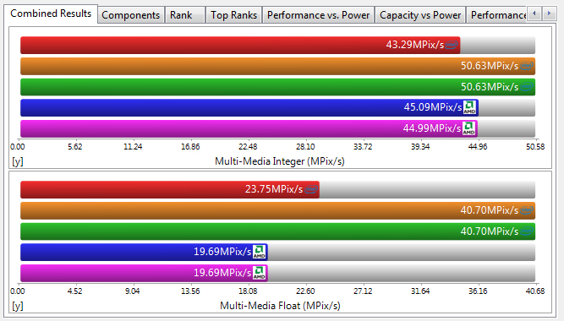Комбинированный график (Combined Results)

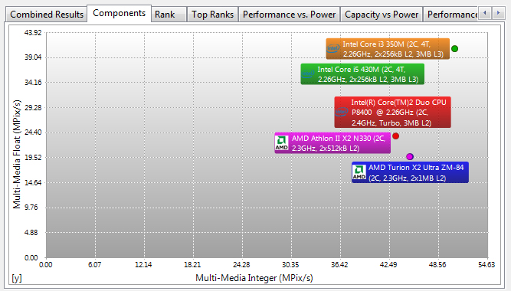 График компонентов (Components)

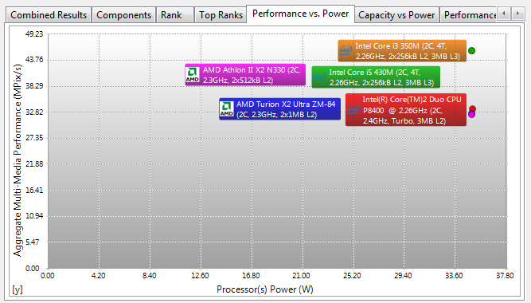 Производительность - Мощность (Performance vs Power)

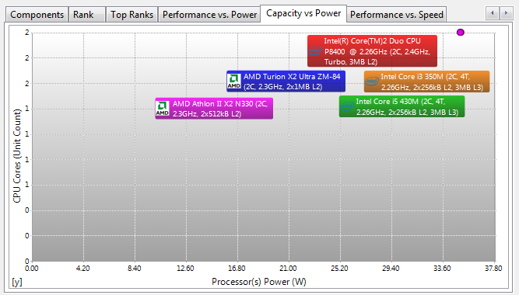 Емкость - Мощность (Capasity vs Power)

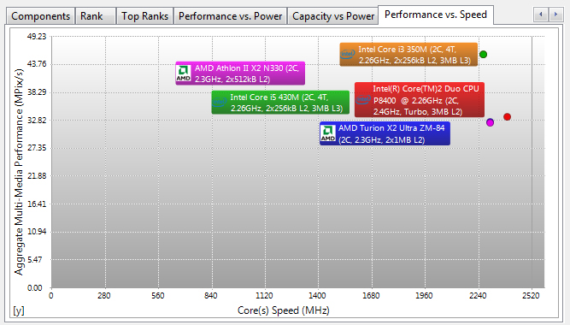 Производительность - Скорость (Performance vs Speed)

# **Многоядерная эффективность**

(Multi-Core Efficiency)

Benchmark the multi-core efficiency of the processors. Shows how efficient the processor cores and their inter-connects are in comparison to other types to other typical processors.

The ability of the cores to process data blocks and pass them to another core for processing (producer-consumer paradigm) of different sizes and different chain sizes is measured. The efficiency of the inter-connect between cores is thus benchmarked; however, the number of cores (and processors) also counts as more data buffers can be processed simultaneously (aka "in flight").

True multi-core processors that have shared L2/L3 caches will thus perform much better than cores that have separate caches and are connected by the traditional FSB.

* Multi-Processor (SMP) support for up to 32/64 CPUs & multi-core (MC)
* Test takes about 1 minute on Core-class PCs.
* **Command Line Switch**: CPUCoreBench
* **Requirements:** Multi-Core processor(s)

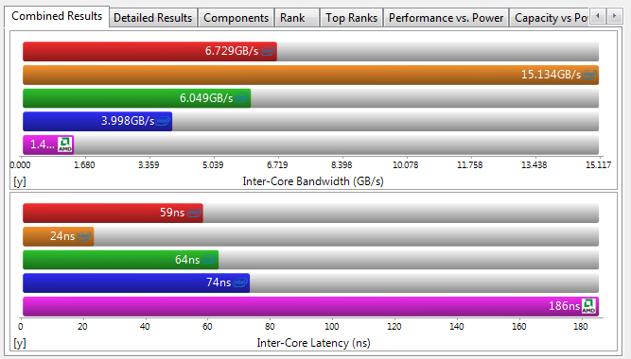

Комбинированный график (Combined Results)

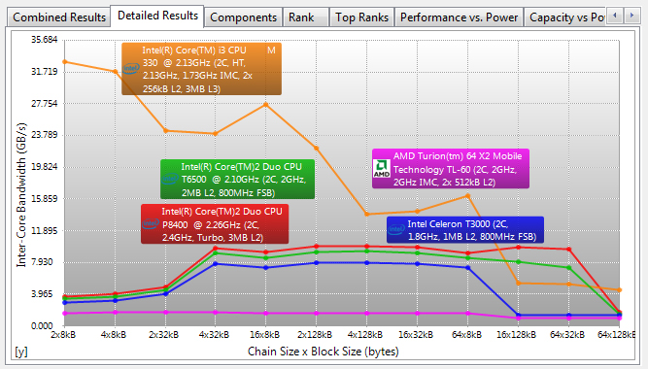

Подробный график (Detailed Results)

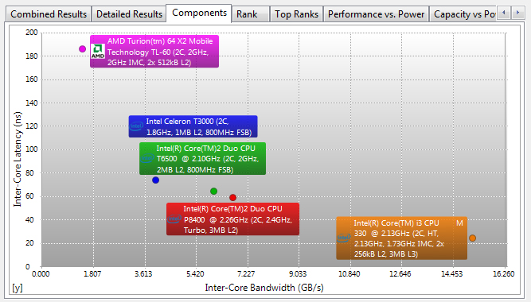

График компонентов (Components)

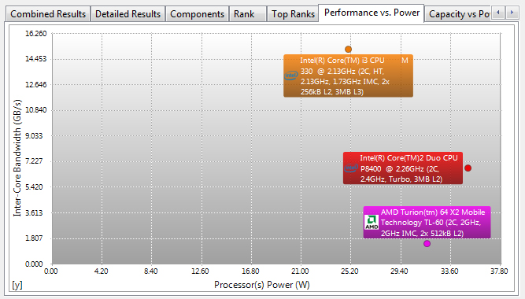

Производительность - Мощность (Performance vs Power)

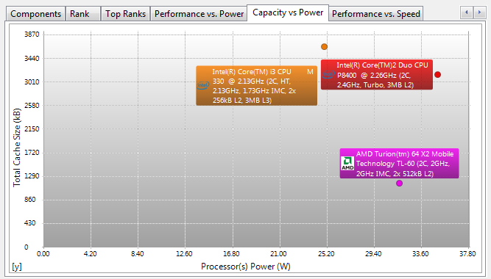

Емкость - Мощность (Capacity vs Power)

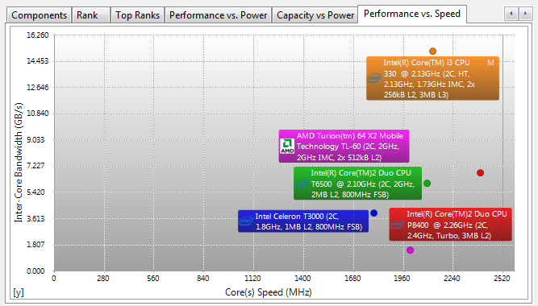

Производительность - Скорость (Performance vs Speed)

|  |  |  |  |  |
| --- | --- | --- | --- | --- |
| Processor Arithmetic | | | | |
|  | | | | |
|  | | **Benchmark Results** | | |
|  | | | Aggregate Arithmetic Performance | 18.66GOPS |
|  | | | Dhrystone ALU | 20.73GIPS |
|  | | | Whetstone iSSE3 | 16.6GFLOPS |
|  | | | Results Interpretation | Higher scores are better. |
|  | | | | |
|  | | **Windows Experience Index** | | |
|  | | | Current Processor(s) | 5.2 |
|  | | | Results Interpretation | Higher scores are better. |
|  | | | | |
|  | | **Performance vs. Speed** | | |
|  | | | Aggregate Arithmetic Performance | 7.79MOPS/MHz |
|  | | | Dhrystone ALU | 8.66MIPS/MHz |
|  | | | Whetstone iSSE3 | 6.93MFLOPS/MHz |
|  | | | Results Interpretation | Higher scores are better. |
|  | | | | |
|  | | **Performance vs. Power** | | |
|  | | | Processor(s) Power | 35.09W |
|  | | | Aggregate Arithmetic Performance | 531.75MOPS/W |
|  | | | Dhrystone ALU | 590.65MIPS/W |
|  | | | Whetstone iSSE3 | 472.87MFLOPS/W |
|  | | | Results Interpretation | Higher scores are better. |
|  | | | | |
|  | | **Performance Test Status** | | |
|  | | | Result ID | Intel(R) Core(TM)2 Duo CPU P8400 @ 2.26GHz (2C, 2.4GHz, Turbo, 3MB L2) |
|  | | | Platform Compliance | x86 |
|  | | | NUMA Support | No |
|  | | | SMP (Multi-Processor) Benchmark | Yes |
|  | | | Total Test Threads | 2 |
|  | | | Multi-Core Test | Yes |
|  | | | Cores per Processor | 2 |
|  | | | SMT (Multi-Threaded) Benchmark | No |
|  | | | Processor Affinity | P0C0T0 P0C1T0 |
|  | | | System Timer | 14.32MHz |
|  | | | Number of Runs | 64000 / 640 |
|  | | | | |
|  | | **Processor** | | |
|  | | | Model | Intel(R) Core(TM)2 Duo CPU P8400 @ 2.26GHz |
|  | | | URL | http://www.intel.com |
|  | | | Speed | 2.4GHz |
|  | | | Peak Processing Performance (PPP) | 19.15GFLOPS |
|  | | | Adjusted Peak Performance (APP) | 5.75WG |
|  | | | Cores per Processor | 2 Unit(s) |
|  | | | Type | Mobile, Dual-Core |
|  | | | Integrated Data Cache | 2x 32kB, Synchronous, Write-Thru, 8-way, 64 byte line size |
|  | | | L2 On-board Cache | 3MB, ECC, Synchronous, ATC, 12-way, 64 byte line size, 2 threads sharing |
|  | | | | |
|  | | **Features** | | |
|  | | | (W)MMX Technology | Yes |
|  | | | SSE Technology | Yes |
|  | | | SSE2 Technology | Yes |
|  | | | SSE3 Technology | Yes |
|  | | | Supplemental SSE3 Technology | Yes |
|  | | | SSE4.1 Technology | Yes |
|  | | | SSE4.2 Technology | No |
|  | | | AVX - Advanced Vector eXtensions | No |
|  | | | FMA - Fused Multiply/Add eXtensions | No |
|  | | | SSE4A Technology | No |
|  | | | FMA4 - 4 Operands Fused Multiply/Add eXtensions | No |
|  | | | HTT - Hyper-Threading Technology | No |
|  | | | | |
|  | | **Performance Tips** | | |
|  | | | Notice 5008 | To change benchmarks, click Options. |
|  | | | Notice 5004 | Synthetic benchmark. May not tally with 'real-life' performance. |
|  | | | Notice 5006 | Only compare the results with ones obtained using the same version! |
|  | | | Tip 2 | Double-click tip or press Enter while a tip is selected for more information about the tip. |
|  | | | | |
| **Processor Multi-Media** | | | | |
|  | | | | |
|  | | **Benchmark Results** | | |
|  | | | Aggregate Multi-Media Performance | 33.52MPix/s |
|  | | | Multi-Media Integer x8 iSSE4.1 | 43.3MPix/s |
|  | | | Multi-Media Float x4 iSSE2 | 23.75MPix/s |
|  | | | Multi-Media Double x2 iSSE2 | 11.88MPix/s |
|  | | | Results Interpretation | Higher scores are better. |
|  | | | | |
|  | | **Windows Experience Index** | | |
|  | | | Current Processor(s) | 5.2 |
|  | | | Results Interpretation | Higher scores are better. |
|  | | | | |
|  | | **Performance vs. Speed** | | |
|  | | | Aggregate Multi-Media Performance | 14.83kPix/s/MHz |
|  | | | Multi-Media Integer x8 iSSE4.1 | 19.15kPix/s/MHz |
|  | | | Multi-Media Float x4 iSSE2 | 10.50kPix/s/MHz |
|  | | | Multi-Media Double x2 iSSE2 | 5.25kPix/s/MHz |
|  | | | Results Interpretation | Higher scores are better. |
|  | | | | |
|  | | **Performance vs. Power** | | |
|  | | | Processor(s) Power | 29.78W |
|  | | | Aggregate Multi-Media Performance | 1125.76kPix/s/W |
|  | | | Multi-Media Integer x8 iSSE4.1 | 1454.03kPix/s/W |
|  | | | Multi-Media Float x4 iSSE2 | 797.52kPix/s/W |
|  | | | Multi-Media Double x2 iSSE2 | 398.96kPix/s/W |
|  | | | Results Interpretation | Higher scores are better. |
|  | | | | |
|  | | **Performance Test Status** | | |
|  | | | Result ID | Intel(R) Core(TM)2 Duo CPU P8400 @ 2.26GHz (2C, 2.26GHz, 3MB L2) |
|  | | | Platform Compliance | x86 |
|  | | | NUMA Support | No |
|  | | | SMP (Multi-Processor) Benchmark | Yes |
|  | | | Total Test Threads | 2 |
|  | | | Multi-Core Test | Yes |
|  | | | Cores per Processor | 2 |
|  | | | SMT (Multi-Threaded) Benchmark | No |
|  | | | Processor Affinity | P0C0T0 P0C1T0 |
|  | | | System Timer | 14.32MHz |
|  | | | Rendered Image Size | 1920x1080 |
|  | | | | |
|  | | **Processor** | | |
|  | | | Model | Intel(R) Core(TM)2 Duo CPU P8400 @ 2.26GHz |
|  | | | URL | http://www.intel.com |
|  | | | Speed | 2.26GHz |
|  | | | Peak Processing Performance (PPP) | 18GFLOPS |
|  | | | Adjusted Peak Performance (APP) | 5.43WG |
|  | | | Cores per Processor | 2 Unit(s) |
|  | | | Type | Mobile, Dual-Core |
|  | | | Integrated Data Cache | 2x 32kB, Synchronous, Write-Thru, 8-way, 64 byte line size |
|  | | | L2 On-board Cache | 3MB, ECC, Synchronous, ATC, 12-way, 64 byte line size, 2 threads sharing |
|  | | | | |
|  | | **Features** | | |
|  | | | (W)MMX Technology | Yes |
|  | | | SSE Technology | Yes |
|  | | | SSE2 Technology | Yes |
|  | | | SSE3 Technology | Yes |
|  | | | Supplemental SSE3 Technology | Yes |
|  | | | SSE4.1 Technology | Yes |
|  | | | SSE4.2 Technology | No |
|  | | | AVX - Advanced Vector eXtensions | No |
|  | | | FMA - Fused Multiply/Add eXtensions | No |
|  | | | SSE4A Technology | No |
|  | | | FMA4 - 4 Operands Fused Multiply/Add eXtensions | No |
|  | | | HTT - Hyper-Threading Technology | No |
|  | | | | |
|  | | **Performance Tips** | | |
|  | | | Notice 5008 | To change benchmarks, click Options. |
|  | | | Notice 5004 | Synthetic benchmark. May not tally with 'real-life' performance. |
|  | | | Notice 5006 | Only compare the results with ones obtained using the same version! |
|  | | | Tip 2 | Double-click tip or press Enter while a tip is selected for more information about the tip. |
|  | | | | |
| **Multi-Core Efficiency** | | | | |
|  | | | | |
|  | | **Benchmark Results** | | |
|  | | | Inter-Core Bandwidth | 6.59GB/s |
|  | | | Results Interpretation | Higher scores are better. |
|  | | | Inter-Core Latency | 59ns |
|  | | | Results Interpretation | Lower scores are better. |
|  | | | | |
|  | | **Windows Experience Index** | | |
|  | | | Current Processor(s) | 5.2 |
|  | | | Results Interpretation | Higher scores are better. |
|  | | | | |
|  | | **Performance vs. Speed** | | |
|  | | | Inter-Core Bandwidth | 2.82MB/s/MHz |
|  | | | Results Interpretation | Higher scores are better. |
|  | | | Inter-Core Latency | 0.02ns/MHz |
|  | | | Results Interpretation | Lower scores are better. |
|  | | | | |
|  | | **Performance vs. Power** | | |
|  | | | Processor(s) Power | 35.09W |
|  | | | Inter-Core Bandwidth | 192.22MB/s/W |
|  | | | Results Interpretation | Higher scores are better. |
|  | | | Inter-Core Latency | 1.68ns/W |
|  | | | Results Interpretation | Lower scores are better. |
|  | | | | |
|  | | **Capacity vs Power** | | |
|  | | | Total Cache Size | 268.00kB/W |
|  | | | Results Interpretation | Higher scores are better. |
|  | | | | |
|  | | **Detailed Benchmark Results** | | |
|  | | | Processor Affinity | CPU0-CPU1 |
|  | | | 2x8kB Blocks Bandwidth | 3.64GB/s |
|  | | | 4x8kB Blocks Bandwidth | 4GB/s |
|  | | | 2x32kB Blocks Bandwidth | 5GB/s |
|  | | | 4x32kB Blocks Bandwidth | 9.75GB/s |
|  | | | 16x8kB Blocks Bandwidth | 9.18GB/s |
|  | | | 2x128kB Blocks Bandwidth | 10GB/s |
|  | | | 4x128kB Blocks Bandwidth | 10GB/s |
|  | | | 16x32kB Blocks Bandwidth | 9.8GB/s |
|  | | | 64x8kB Blocks Bandwidth | 9.17GB/s |
|  | | | 16x128kB Blocks Bandwidth | 9GB/s |
|  | | | 64x32kB Blocks Bandwidth | 8.62GB/s |
|  | | | 64x128kB Blocks Bandwidth | 1.5GB/s |
|  | | | | |
|  | | **Performance Test Status** | | |
|  | | | Result ID | Intel(R) Core(TM)2 Duo CPU P8400 @ 2.26GHz (2C, 2.4GHz, Turbo, 3MB L2) |
|  | | | Platform Compliance | x86 |
|  | | | Buffering Used | No |
|  | | | NUMA Support | No |
|  | | | SMP (Multi-Processor) Benchmark | Yes |
|  | | | Total Test Threads | 2 |
|  | | | Multi-Core Test | Yes |
|  | | | Cores per Processor | 2 |
|  | | | System Timer | 14.32MHz |
|  | | | Page Size | 4kB |
|  | | | Use Large Memory Pages | No |
|  | | | | |
|  | | **Processor** | | |
|  | | | Model | Intel(R) Core(TM)2 Duo CPU P8400 @ 2.26GHz |
|  | | | URL | http://www.intel.com |
|  | | | Speed | 2.4GHz |
|  | | | Peak Processing Performance (PPP) | 19.15GFLOPS |
|  | | | Adjusted Peak Performance (APP) | 5.75WG |
|  | | | Cores per Processor | 2 Unit(s) |
|  | | | Type | Mobile, Dual-Core |
|  | | | Integrated Data Cache | 2x 32kB, Synchronous, Write-Thru, 8-way, 64 byte line size |
|  | | | L2 On-board Cache | 3MB, ECC, Synchronous, ATC, 12-way, 64 byte line size, 2 threads sharing |
|  | | | | |
|  | | **Performance Tips** | | |
|  | | | Notice 5008 | To change benchmarks, click Options. |
|  | | | Notice 5004 | Synthetic benchmark. May not tally with 'real-life' performance. |
|  | | | Notice 5006 | Only compare the results with ones obtained using the same version! |
|  | | | Tip 11 | Use the tab to switch between Detailed and Combined charts. |
|  | | | Warning 5010 | Cannot use Large Memory Pages due to lack of privileges. |
|  | | | Tip 2 | Double-click tip or press Enter while a tip is selected for more information about the tip. |
|  | | | | |
| **Processors** | | | | |
|  | | | | |
|  | **CPU 1 [Processor 0, Core 0, Thread 0]** | | | |
|  | | **Processor** | | |
|  | | | Manufacturer | Intel |
|  | | | Model | Intel(R) Core(TM)2 Duo CPU P8400 @ 2.26GHz |
|  | | | URL | http://www.intel.com |
|  | | | Speed | 2.4GHz |
|  | | | Peak Processing Performance (PPP) | 19.15GFLOPS |
|  | | | Adjusted Peak Performance (APP) | 5.75WG |
|  | | | Cores per Processor | 2 Unit(s) |
|  | | | Threads per Core | 1 Unit(s) |
|  | | | Type | Mobile, Dual-Core |
|  | | | Bus | Intel AGTL+ |
|  | | | Package | FC µPGA (Socket P) |
|  | | | Maximum Speed | 2.4GHz / 4x 267MHz (1GHz) |
|  | | | Multiplier | 9x |
|  | | | Minimum/Maximum/Turbo Multiplier | 3x - 9x |
|  | | | Generation | G8 |
|  | | | Name | C2DP (Penryn) Mobile Core 2 Duo 45nm 2.1-2.8GHz 1.0-1.15V |
|  | | | Revision/Stepping | 0 / 17 / 6 |
|  | | | Stepping Mask | C0/M0 |
|  | | | Microcode | MU0617060C |
|  | | | Core Voltage Rating | 1.200V |
|  | | | Min/Max Core Voltage | 0.713V - 1.200V |
|  | | | Maximum Power | 35.09W |
|  | | | Maximum Physical / Virtual Addressing | 36-bit / 48-bit |
|  | | | Native Page Size | 4kB |
|  | | | Large Page Size | 2MB |
|  | | | Part Number | PPN12345678901234567 |
|  | | | Asset Tag | PATN1234567890123456 |
|  | | | Serial Number | PSN12345678901234567 |
|  | | | | |
|  | | **Co-Processor (FPU)** | | |
|  | | | Speed | 2.4GHz |
|  | | | Type | Integrated |
|  | | | Revision/Stepping | 0 / 17 / 6 |
|  | | | | |
|  | | **Cache Information** | | |
|  | | | Integrated Data Cache | 32kB, Synchronous, Write-Thru, 8-way, 64 byte line size |
|  | | | Integrated Instruction Cache | 32kB, Synchronous, Write-Back, 8-way, 64 byte line size |
|  | | | L2 On-board Cache | 3MB, ECC, Synchronous, ATC, 12-way, 64 byte line size, 2 threads sharing |
|  | | | L2 Cache Multiplier | 1x |
|  | | | | |
|  | | **Upgradeability** | | |
|  | | | Socket/Slot | Socket 478 |
|  | | | Supported Speed(s) | 2.4GHz |
|  | | | | |
|  | | **Sensors 1** | | |
|  | | | Model | Intel Core CPU [P0, C2, T105] |
|  | | | Version | 23.06 |
|  | | | Mainboard Specific Support | No |
|  | | | | |
|  | | **Power Rating(s)** | | |
|  | | | CPU Core Power | 35.09W |
|  | | | | |
|  | | **Sensors** | | |
|  | | | CPU 1 Temperature | 51.00°C td |
|  | | | | |
|  | | **Features** | | |
|  | | | FPU - Integrated Co-Processor | Yes |
|  | | | VME - Virtual Mode Extensions | Yes |
|  | | | DE - Debugging Extension | Yes |
|  | | | PSE - Page Size Extension | Yes |
|  | | | TSC - Time Stamp Counter | Yes |
|  | | | MSR - Model Specific Registers | Yes |
|  | | | PAE - Physical Address Extension | Yes |
|  | | | MCE - Machine Check Exception | Yes |
|  | | | CX8 - Compare & Exchange 8-bytes Instruction | Yes |
|  | | | APIC - Local APIC Integrated | Yes |
|  | | | SEP - Fast System Call | Yes |
|  | | | MTRR - Memory Type Range Registers | Yes |
|  | | | PGE - Page Global Enable | Yes |
|  | | | MCA - Machine Check Architecture | Yes |
|  | | | PAT - Page Attribute Table | Yes |
|  | | | PSE36 - 36-bit Page Size Extension | Yes |
|  | | | PSN - Unique Serial Number | No |
|  | | | CLF - Cache Line Flush Support | Yes |
|  | | | DS - Debug Trace & EMON Store | Yes |
|  | | | ACPI - Software Clock Control | Yes |
|  | | | (W)MMX Technology | Yes |
|  | | | FXSR - Fast Float Save & Restore | Yes |
|  | | | SSE Technology | Yes |
|  | | | SSE2 Technology | Yes |
|  | | | SS - Self Snoop | Yes |
|  | | | HTT - Hyper-Threading Technology | Yes |
|  | | | TM - Thermal Monitor | Yes |
|  | | | PBE - Pending Break Enable | Yes |
|  | | | IA64 Technology | No |
|  | | | SSE3 Technology | Yes |
|  | | | PCLMULQDQ - Carryless Multiplication | No |
|  | | | MON - Monitor/MWait | Yes |
|  | | | DSCPL - CPL qualified Debug Store | Yes |
|  | | | VMX - Virtual Machine eXtensions | Yes |
|  | | | SMX - Trust Execution Technology | Yes |
|  | | | EIST - Enhanced SpeedStep Technology | Yes |
|  | | | TM2 - Thermal Monitor 2 | Yes |
|  | | | Supplemental SSE3 Technology | Yes |
|  | | | CID - Context ID | No |
|  | | | FMA - Fused Multiply/Add eXtensions | No |
|  | | | CX16 - Compare & Exchange 16-bytes Instruction | Yes |
|  | | | xTPR - Send Task Priority Messages | Yes |
|  | | | PDCM - PerfMon and Debug | Yes |
|  | | | DCA - Direct Cache Access | No |
|  | | | SSE4.1 Technology | Yes |
|  | | | SSE4.2 Technology | No |
|  | | | x2APIC - v2 APIC Mode | No |
|  | | | MOVBE - Byte-swap Load/Store | No |
|  | | | POPCNT - Pop Count | No |
|  | | | AES - Cryptography Support | No |
|  | | | XSAVE - eXtended State Management | No |
|  | | | OSXSAVE - OS Enabled eXtended States | No |
|  | | | AVX - Advanced Vector eXtensions | No |
|  | | | CVT16 - Half Precision Float Conversion | No |
|  | | | GIH - Guest in Hypervisor | No |
|  | | | DAZ - Denormals Are Zero | Yes |
|  | | | | |
|  | | **Extended Features** | | |
|  | | | EMMX - Extended MMX Technology | No |
|  | | | 3DNow! Technology | No |
|  | | | Extended 3DNow! Technology | No |
|  | | | XD/NX - No-execute Page Protection | Yes |
|  | | | AMD64/EM64T Technology | Yes |
|  | | | RDTSCP - Serialised TSC | No |
|  | | | P1GB - 1GB Large Page Support | No |
|  | | | SVM - Secure Virtual Machine | No |
|  | | | AltMovCr8 - Lock Move CRn | No |
|  | | | ABM - Advanced Bit Manipulation | No |
|  | | | SSE4A Technology | No |
|  | | | MASSE - Misaligned SSE Mode | No |
|  | | | 3D Now! Prefetch Technology | No |
|  | | | XOP - eXtended OPerations | No |
|  | | | LWP - LightWeight Profiling Support | No |
|  | | | FMA4 - 4 Operands Fused Multiply/Add eXtensions | No |
|  | | | TCE - Translation Cache eXtension | No |
|  | | | NID - Multi-Node Support | No |
|  | | | ToP - Extended Topology | No |
|  | | | | |
|  | | **Power Management Features** | | |
|  | | | DTSC - Digital Thermal Sensor Capability | Yes |
|  | | | IDA - Dynamic Acceleration Technology | No |
|  | | | HCFC - Hardware Coordination Feedback/Effective Frequency | Yes |
|  | | | | |
|  | | **Virtual Machine Features** | | |
|  | | | Version | 0.13 |
|  | | | Address Width Limited to 32-bit | No |
|  | | | Dual-Monitor Interrupts/System Management Mode | Yes |
|  | | | Report Information on VMExit | Yes |
|  | | | Ex Capability MSR Supported | No |
|  | | | | |
|  | | **Advanced Settings** | | |
|  | | | Fast Strings | Yes |
|  | | | PM - Performance Monitoring Support | Yes |
|  | | | PEBS - Precise Event Based Sampling Support | Yes |
|  | | | XE Operation Enabled | No |
|  | | | Hardware Prefetcher Enabled | Yes |
|  | | | Adjacent Cache Line Prefetch Enabled | Yes |
|  | | | Data Cache Prefetcher Enabled | Yes |
|  | | | Instruction Prefetcher Enabled | Yes |
|  | | | TM2 - Thermal Monitor 2 | Yes |
|  | | | EIST - Enhanced SpeedStep Technology | Yes |
|  | | | Average Clock Speed | 97.54% |
|  | **CPU 2 [Processor 0, Core 1, Thread 0]** | | | |
|  | | **Processor** | | |
|  | | | Manufacturer | Intel |
|  | | | Model | Intel(R) Core(TM)2 Duo CPU P8400 @ 2.26GHz |
|  | | | URL | http://www.intel.com |
|  | | | Speed | 2.4GHz |
|  | | | Peak Processing Performance (PPP) | 19.15GFLOPS |
|  | | | Adjusted Peak Performance (APP) | 5.75WG |
|  | | | Cores per Processor | 2 Unit(s) |
|  | | | Threads per Core | 1 Unit(s) |
|  | | | Type | Mobile, Dual-Core |
|  | | | Bus | Intel AGTL+ |
|  | | | Package | FC µPGA (Socket P) |
|  | | | Maximum Speed | 2.4GHz / 4x 267MHz (1GHz) |
|  | | | Multiplier | 9x |
|  | | | Minimum/Maximum/Turbo Multiplier | 3x - 9x |
|  | | | Generation | G8 |
|  | | | Name | C2DP (Penryn) Mobile Core 2 Duo 45nm 2.1-2.8GHz 1.0-1.15V |
|  | | | Revision/Stepping | 0 / 17 / 6 |
|  | | | Stepping Mask | C0/M0 |
|  | | | Microcode | MU0617060C |
|  | | | Core Voltage Rating | 1.200V |
|  | | | Min/Max Core Voltage | 0.713V - 1.200V |
|  | | | Maximum Power | 35.09W |
|  | | | Maximum Physical / Virtual Addressing | 36-bit / 48-bit |
|  | | | Native Page Size | 4kB |
|  | | | Large Page Size | 2MB |
|  | | | Part Number | PPN12345678901234567 |
|  | | | Asset Tag | PATN1234567890123456 |
|  | | | Serial Number | PSN12345678901234567 |
|  | | | | |
|  | | **Co-Processor (FPU)** | | |
|  | | | Speed | 2.4GHz |
|  | | | Type | Integrated |
|  | | | Revision/Stepping | 0 / 17 / 6 |
|  | | | | |
|  | | **Cache Information** | | |
|  | | | Integrated Data Cache | 32kB, Synchronous, Write-Thru, 8-way, 64 byte line size |
|  | | | Integrated Instruction Cache | 32kB, Synchronous, Write-Back, 8-way, 64 byte line size |
|  | | | L2 On-board Cache | 3MB, ECC, Synchronous, ATC, 12-way, 64 byte line size, 2 threads sharing |
|  | | | L2 Cache Multiplier | 1x |
|  | | | | |
|  | | **Upgradeability** | | |
|  | | | Socket/Slot | Socket 478 |
|  | | | Supported Speed(s) | 2.4GHz |
|  | | | | |
|  | | **Sensors 1** | | |
|  | | | Model | Intel Core CPU [P0, C2, T105] |
|  | | | Version | 23.06 |
|  | | | Mainboard Specific Support | No |
|  | | | | |
|  | | **Power Rating(s)** | | |
|  | | | CPU Core Power | 35.09W |
|  | | | | |
|  | | **Sensors** | | |
|  | | | CPU 1 Temperature | 52.00°C td |
|  | | | | |
|  | | **Features** | | |
|  | | | FPU - Integrated Co-Processor | Yes |
|  | | | VME - Virtual Mode Extensions | Yes |
|  | | | DE - Debugging Extension | Yes |
|  | | | PSE - Page Size Extension | Yes |
|  | | | TSC - Time Stamp Counter | Yes |
|  | | | MSR - Model Specific Registers | Yes |
|  | | | PAE - Physical Address Extension | Yes |
|  | | | MCE - Machine Check Exception | Yes |
|  | | | CX8 - Compare & Exchange 8-bytes Instruction | Yes |
|  | | | APIC - Local APIC Integrated | Yes |
|  | | | SEP - Fast System Call | Yes |
|  | | | MTRR - Memory Type Range Registers | Yes |
|  | | | PGE - Page Global Enable | Yes |
|  | | | MCA - Machine Check Architecture | Yes |
|  | | | PAT - Page Attribute Table | Yes |
|  | | | PSE36 - 36-bit Page Size Extension | Yes |
|  | | | PSN - Unique Serial Number | No |
|  | | | CLF - Cache Line Flush Support | Yes |
|  | | | DS - Debug Trace & EMON Store | Yes |
|  | | | ACPI - Software Clock Control | Yes |
|  | | | (W)MMX Technology | Yes |
|  | | | FXSR - Fast Float Save & Restore | Yes |
|  | | | SSE Technology | Yes |
|  | | | SSE2 Technology | Yes |
|  | | | SS - Self Snoop | Yes |
|  | | | HTT - Hyper-Threading Technology | Yes |
|  | | | TM - Thermal Monitor | Yes |
|  | | | PBE - Pending Break Enable | Yes |
|  | | | IA64 Technology | No |
|  | | | SSE3 Technology | Yes |
|  | | | PCLMULQDQ - Carryless Multiplication | No |
|  | | | MON - Monitor/MWait | Yes |
|  | | | DSCPL - CPL qualified Debug Store | Yes |
|  | | | VMX - Virtual Machine eXtensions | Yes |
|  | | | SMX - Trust Execution Technology | Yes |
|  | | | EIST - Enhanced SpeedStep Technology | Yes |
|  | | | TM2 - Thermal Monitor 2 | Yes |
|  | | | Supplemental SSE3 Technology | Yes |
|  | | | CID - Context ID | No |
|  | | | FMA - Fused Multiply/Add eXtensions | No |
|  | | | CX16 - Compare & Exchange 16-bytes Instruction | Yes |
|  | | | xTPR - Send Task Priority Messages | Yes |
|  | | | PDCM - PerfMon and Debug | Yes |
|  | | | DCA - Direct Cache Access | No |
|  | | | SSE4.1 Technology | Yes |
|  | | | SSE4.2 Technology | No |
|  | | | x2APIC - v2 APIC Mode | No |
|  | | | MOVBE - Byte-swap Load/Store | No |
|  | | | POPCNT - Pop Count | No |
|  | | | AES - Cryptography Support | No |
|  | | | XSAVE - eXtended State Management | No |
|  | | | OSXSAVE - OS Enabled eXtended States | No |
|  | | | AVX - Advanced Vector eXtensions | No |
|  | | | CVT16 - Half Precision Float Conversion | No |
|  | | | GIH - Guest in Hypervisor | No |
|  | | | DAZ - Denormals Are Zero | Yes |
|  | | | | |
|  | | **Extended Features** | | |
|  | | | EMMX - Extended MMX Technology | No |
|  | | | 3DNow! Technology | No |
|  | | | Extended 3DNow! Technology | No |
|  | | | XD/NX - No-execute Page Protection | Yes |
|  | | | AMD64/EM64T Technology | Yes |
|  | | | RDTSCP - Serialised TSC | No |
|  | | | P1GB - 1GB Large Page Support | No |
|  | | | SVM - Secure Virtual Machine | No |
|  | | | AltMovCr8 - Lock Move CRn | No |
|  | | | ABM - Advanced Bit Manipulation | No |
|  | | | SSE4A Technology | No |
|  | | | MASSE - Misaligned SSE Mode | No |
|  | | | 3D Now! Prefetch Technology | No |
|  | | | XOP - eXtended OPerations | No |
|  | | | LWP - LightWeight Profiling Support | No |
|  | | | FMA4 - 4 Operands Fused Multiply/Add eXtensions | No |
|  | | | TCE - Translation Cache eXtension | No |
|  | | | NID - Multi-Node Support | No |
|  | | | ToP - Extended Topology | No |
|  | | | | |
|  | | **Power Management Features** | | |
|  | | | DTSC - Digital Thermal Sensor Capability | Yes |
|  | | | IDA - Dynamic Acceleration Technology | No |
|  | | | HCFC - Hardware Coordination Feedback/Effective Frequency | Yes |
|  | | | | |
|  | | **Virtual Machine Features** | | |
|  | | | Version | 0.13 |
|  | | | Address Width Limited to 32-bit | No |
|  | | | Dual-Monitor Interrupts/System Management Mode | Yes |
|  | | | Report Information on VMExit | Yes |
|  | | | Ex Capability MSR Supported | No |
|  | | | | |
|  | | **Advanced Settings** | | |
|  | | | Fast Strings | Yes |
|  | | | PM - Performance Monitoring Support | Yes |
|  | | | PEBS - Precise Event Based Sampling Support | Yes |
|  | | | XE Operation Enabled | No |
|  | | | Hardware Prefetcher Enabled | Yes |
|  | | | Adjacent Cache Line Prefetch Enabled | Yes |
|  | | | Data Cache Prefetcher Enabled | Yes |
|  | | | Instruction Prefetcher Enabled | Yes |
|  | | | TM2 - Thermal Monitor 2 | Yes |
|  | | | EIST - Enhanced SpeedStep Technology | Yes |
|  | | | Average Clock Speed | 96.26% |